TUWEZESHE AKINA DADA (Spotlight) LEADERSHIP & FELLOWSHIP PROGRAMME 2021
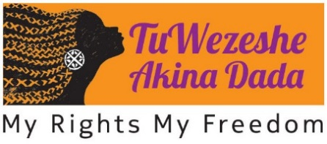
The TuWezeshe Akina Dada is an international program which seeks to nurture a generation of young women from FGM-affected communities [Fellows] into effective leaders in the campaign against FGM. The TuWezeshe Fellowship incorporates a bespoke leadership training for women from FGM-affected communities aged 18-30 years who have a keen interest in research and FGM advocacy and are based in Europe.
During this training, participants are exposed to concepts of self-awareness, power theories, and effective project management etc, after which Fellows are equipped with the skills needed and a grant to implement their own social action project.
TuWezeshe Fellows benefit from a mentoring relationship with a woman-leader with expertise in FGM-advocacy who supports them in the realisation of their social action research group project. From lobbying policy makers, building new networks and working with local communities; TuWezeshe understands that the fight for women’s rights is collective and multidisciplinary. This is reflected in the growing network of TuWezeshe Fellows and Mentors both in the EU, the UK and in Africa.
This Europe 2021 TuWezeshe programme will be co-facilitated in English and French. French speaking FGM-affected community members are strongly encouraged to apply.
LEADERSHIP TRAINING PROGRAM
The programme will commence with a virtual leadership training. Participants will study and engage in key concepts which are essential to effective leadership in taking action against FGM. The training includes:
- Introduction to power theories, personal agency and spaces of influence;
- The art of self-care;
- Feminist theories;
- Understanding SGBV and FGM
- Effective leadership - communication change strategies and public speaking;
- Understanding social action research;
- Project planning, monitoring and evaluating a Social Action Research Project
After successfully completing the leadership and research training, Fellows will be expected to design a social action research project and will receive a seed grant to pursue and implement the Social Action Research Project.

MENTORING PROGRAM
Participants will be paired with a Mentor who will support and guide them throughout the Fellowship. Fellows and Mentors will be partnered based on interests and experience. Previous TuWezeshe Mentors have come from varying backgrounds and professional experiences including government staff, barristers, NGO professionals, art curators and journalists. The rich network of Mentors ensures that TuWezeshe Fellows gain first-hand experience and unique insights into the work currently being done at the forefront of SGBV activism.
IMPORTANT:
Please note that the TuWezeshe Akina Dada ‘Accelerating African-led FGM Change Makers’ is being led by FORWARD in partnership with the following organisations: Akili Dada (Kenya), Think Young Women (the Gambia) and End FGM European Network (Belgium).
This programme is funded by the UNFPA Spotlight Programme.
All EU residents must apply for the fellowship through the End FGM European Network via ibenboulerbah@endfgm.eu and UK residents must apply through FORWARD via forward@forwarduk.org.uk

